|  |  |  |  |
| --- | --- | --- | --- |
| **Name of Student: NINAD AVINASH PATIL** | | | |
| **Roll No: 33** | | **Lab Practical Number: 3(A).3** | |
| **Title of Lab Practical: Create a class person. Write an application to serialize objects of person class in a File. Provide search facility on Person ID and display the result in List View.** | | | |
| **DOP: 19/03/2021** | | **DOS: 24/03/2021** | |
| **CO Mapped: CO1** | **PO Mapped: PO3, PO5, PO7,**  **PO12, PSO1, PSO2** | **Faculty Signature:** | **Marks:** |

**Practical No 3(A).3**

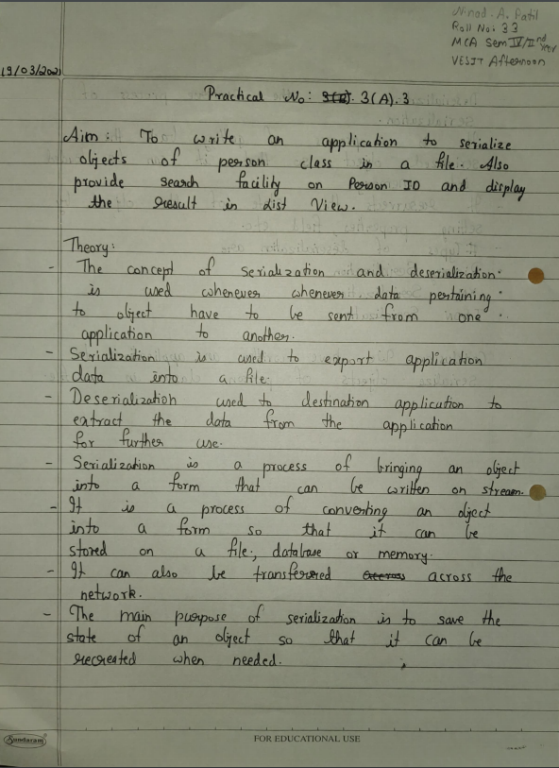

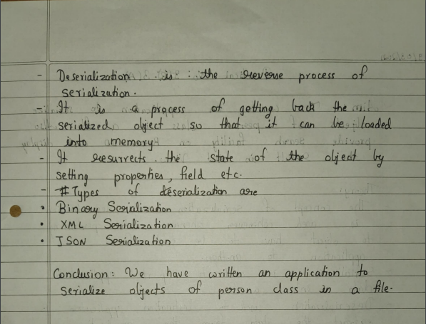

**Code:**

using System;

using System.Collections.Generic;

using System.ComponentModel;

using System.Data;

using System.Drawing;

using System.Linq;

using System.Text;

using System.Windows.Forms;

using System.IO;

using System.Runtime.Serialization;

using System.Runtime.Serialization.Formatters.Binary;

namespace serialize

{

public partial class Form1 : Form

{

public Form1()

{

InitializeComponent();

}

Person p = new Person();

IFormatter f = new BinaryFormatter();

private string path = @"E:\\serialize.txt";

private void button1_Click(object sender, EventArgs e)

{

p.ID = textBox1.Text;

p.Name = textBox2.Text;

Stream s = new FileStream(path, FileMode.OpenOrCreate, FileAccess.Write);

f.Serialize(s, p);

s.Close();

label3.Text = "Successfully serialized data";

}

private void button2_Click(object sender, EventArgs e)

{

Stream s1 = new FileStream(path, FileMode.Open, FileAccess.Read);

Person objnew = (Person)f.Deserialize(s1);

if (objnew.ID == textBox1.Text)

{

listView1.Items.Add(objnew.Name + Environment.NewLine);

label3.Text = "Successfully serched deserialized by ID";

}

else

{

label3.Text = "ID not found";

}

}

[Serializable]

class Person

{

public String ID;

public String Name;

}

private void button3_Click(object sender, EventArgs e)

{

listView1.Clear();

textBox1.Clear();

textBox2.Clear();

label3.Text = " ";

}

}

}

**Output:**

